CHAPTER 9
I WANTED to go and look at a place right about the
middle of the island that I'd found when I was
exploring; so we started and soon got to it, because
the island was only three miles long and a quarter of a
mile wide.
Only 3 miles long and ¼ mile wide? Does that sound like a small or a large river island to you? At its widest, how wide is the Mississippi River? How wide is the Barren River?
This place was a tolerable long, steep hill or ridge
about forty foot high. We had a rough time getting
to the top, the sides was so steep and the bushes so
thick. We tramped and clumb around all over it, and
by and by found a good big cavern in the rock, most
up to the top on the side towards Illinois. The cavern
was as big as two or three rooms bunched together,
and Jim could stand up straight in it. It was cool in
there. Jim was for putting our traps in there right
away, but I said we didn't want to be climbing up and
down there all the time.
Jim said if we had the canoe hid in a good place,
and had all the traps in the cavern, we could rush there
if anybody was to come to the island, and they would
never find us without dogs. And, besides, he said
them little birds had said it was going to rain, and did
I want the things to get wet?
So we went back and got the canoe, and paddled up
abreast the cavern, and lugged all the traps up there.
Then we hunted up a place close by to hide the canoe
in, amongst the thick willows. We took some fish off
of the lines and set them again, and begun to get ready
for dinner.
The door of the cavern was big enough to roll a
hogshead in, and on one side of the door the floor
stuck out a little bit, and was flat and a good place to
build a fire on. So we built it there and cooked
dinner.
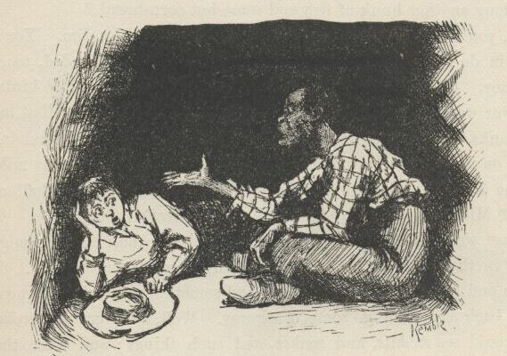
We spread the blankets inside for a carpet, and eat
our dinner in there. We put all the other things handy
at the back of the cavern. Pretty soon it darkened up,
and begun to thunder and lighten; so the birds was
right about it. Directly it begun to rain, and it rained
like all fury, too, and I never see the wind blow so.
It was one of these regular summer storms. It would
get so dark that it looked all blue-black outside, and
lovely; and the rain would thrash along by so thick
that the trees off a little ways looked dim and spider-
webby; and here would come a blast of wind that
would bend the trees down and turn up the pale under-
side of the leaves; and then a perfect ripper of a gust
would follow along and set the branches to tossing
their arms as if they was just wild; and next, when it
was just about the bluest and blackest -- FST! it was as
bright as glory, and you'd have a little glimpse of tree-
tops a-plunging about away off yonder in the storm,
hundreds of yards further than you could see before;
dark as sin again in a second, and now you'd hear the
thunder let go with an awful crash, and then go rum-
bling, grumbling, tumbling, down the sky towards the
under side of the world, like rolling empty barrels
down stairs -- where it's long stairs and they bounce a
good deal, you know.
"Jim, this is nice," I says. "I wouldn't want to
be nowhere else but here. Pass me along another
hunk of fish and some hot corn-bread."
"Well, you wouldn't a ben here 'f it hadn't a ben
for Jim. You'd a ben down dah in de woods widout
any dinner, en gittn' mos' drownded, too; dat you
would, honey. Chickens knows when it's gwyne to
rain, en so do de birds, chile."
Is Jim just tooting his own horn because he likes bragging on himself? What is the logic behind Jim reminding Huck that he has helped him out here?
The river went on raising and raising for ten or
twelve days, till at last it was over the banks. The
water was three or four foot deep on the island in the
low places and on the Illinois bottom. On that side it
was a good many miles wide, but on the Missouri side
it was the same old distance across -- a half a mile --
because the Missouri shore was just a wall of high
bluffs.
Daytimes we paddled all over the island in the canoe,
It was mighty cool and shady in the deep woods, even
if the sun was blazing outside. We went winding in
and out amongst the trees, and sometimes the vines
hung so thick we had to back away and go some other
way. Well, on every old broken-down tree you could
see rabbits and snakes and such things; and when
the island had been overflowed a day or two they got
so tame, on account of being hungry, that you could
paddle right up and put your hand on them if you
wanted to; but not the snakes and turtles -- they would
slide off in the water. The ridge our cavern was in
was full of them. We could a had pets enough if we'd
wanted them.
One night we catched a little section of a lumber
raft -- nice pine planks. It was twelve foot wide and
about fifteen or sixteen foot long, and the top stood
above water six or seven inches -- a solid, level floor.
We could see saw-logs go by in the daylight some-
times, but we let them go; we didn't show ourselves
in daylight.
Another night when we was up at the head of the
island, just before daylight, here comes a frame-house
down, on the west side. She was a two-story, and
tilted over considerable. We paddled out and got
aboard -- clumb in at an upstairs window. But it was
too dark to see yet, so we made the canoe fast and set
in her to wait for daylight.
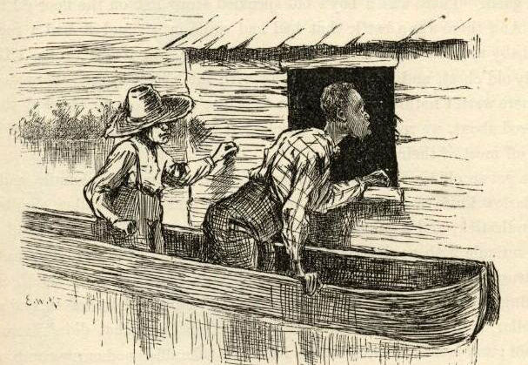
The light begun to come before we got to the foot
of the island. Then we looked in at the window. We
could make out a bed, and a table, and two old chairs,
and lots of things around about on the floor, and there
was clothes hanging against the wall. There was
something laying on the floor in the far corner that
looked like a man. So Jim says:
"Hello, you!"
But it didn't budge. So I hollered again, and then
Jim says:
"De man ain't asleep -- he's dead. You hold still
-- I'll go en see."
He went, and bent down and looked, and says:
"It's a dead man. Yes, indeedy; naked, too.
He's ben shot in de back. I reck'n he's ben dead
two er three days. Come in, Huck, but doan' look at
his face -- it's too gashly."
I didn't look at him at all. Jim throwed some old
rags over him, but he needn't done it; I didn't want
to see him. There was heaps of old greasy cards
scattered around over the floor, and old whisky bottles,
and a couple of masks made out of black cloth; and
all over the walls was the ignorantest kind of words
and pictures made with charcoal. There was two old
dirty calico dresses, and a sun-bonnet, and some
women's underclothes hanging against the wall, and
some men's clothing, too. We put the lot into the
canoe -- it might come good. There was a boy's old
speckled straw hat on the floor; I took that, too.
And there was a bottle that had had milk in it, and it
had a rag stopper for a baby to suck. We would a
took the bottle, but it was broke. There was a seedy
old chest, and an old hair trunk with the hinges broke.
They stood open, but there warn't nothing left in them
that was any account. The way things was scattered
about we reckoned the people left in a hurry, and
warn't fixed so as to carry off most of their stuff.
What does Huck mean by “it might come good”?
We got an old tin lantern, and a butcher-knife with-
out any handle, and a bran-new Barlow knife worth
two bits in any store, and a lot of tallow candles, and a
tin candlestick, and a gourd, and a tin cup, and a ratty
old bedquilt off the bed, and a reticule with needles
and pins and beeswax and buttons and thread and all
such truck in it, and a hatchet and some nails, and a
fishline as thick as my little finger with some mon-
strous hooks on it, and a roll of buckskin, and a
leather dog-collar, and a horseshoe, and some vials of
medicine that didn't have no label on them; and just
as we was leaving I found a tolerable good curry-comb,
and Jim he found a ratty old fiddle-bow, and a wooden
leg. The straps was broke off of it, but, barring that,
it was a good enough leg, though it was too long for
me and not long enough for Jim, and we couldn't find
the other one, though we hunted all around.
And so, take it all around, we made a good haul.
When we was ready to shove off we was a quarter of a
mile below the island, and it was pretty broad day; so
I made Jim lay down in the canoe and cover up with
the quilt, because if he set up people could tell he was
a slave a good ways off. I paddled over to the
Illinois shore, and drifted down most a half a mile
doing it. I crept up the dead water under the bank,
and hadn't no accidents and didn't see nobody. We
got home all safe.
Based on what Huck and Jim saw, what do you think happened at this murder scene?

CHAPTER 10
AFTER breakfast I wanted to talk about the dead
man and guess out how he come to be killed, but
Jim didn't want to. He said it would fetch bad luck;
and besides, he said, he might come and ha'nt us; he
said a man that warn't buried was more likely to go a-
ha'nting around than one that was planted and com-
fortable. That sounded pretty reasonable, so I didn't
say no more; but I couldn't keep from studying over
it and wishing I knowed who shot the man, and what
they done it for.
We rummaged the clothes we'd got, and found eight
dollars in silver sewed up in the lining of an old blanket
overcoat. Jim said he reckoned the people in that
house stole the coat, because if they'd a knowed the
money was there they wouldn't a left it. I said I
reckoned they killed him, too; but Jim didn't want to
talk about that. I says:
"Now you think it's bad luck; but what did you
say when I fetched in the snake-skin that I found on
the top of the ridge day before yesterday? You said
it was the worst bad luck in the world to touch a
snake-skin with my hands. Well, here's your bad
luck! We've raked in all this truck and eight dollars
besides. I wish we could have some bad luck like this
every day, Jim."
What is something you have heard growing up that is supposed to bring bad luck to people?
"Never you mind, honey, never you mind. Don't
you git too peart. It's a-comin'. Mind I tell you,
it's a-comin'."
It did come, too. It was a Tuesday that we had
that talk. Well, after dinner Friday we was laying
around in the grass at the upper end of the ridge, and
got out of tobacco. I went to the cavern to get some,
and found a rattlesnake in there. I killed him, and
curled him up on the foot of Jim's blanket, ever so
natural, thinking there'd be some fun when Jim found
him there. Well, by night I forgot all about the
snake, and when Jim flung himself down on the blanket
while I struck a light the snake's mate was there, and
bit him.
He jumped up yelling, and the first thing the light
showed was the varmint curled up and ready for
another spring. I laid him out in a second with a
stick, and Jim grabbed pap's whisky-jug and begun to
pour it down.
He was barefooted, and the snake bit him right on
the heel. That all comes of my being such a fool as
to not remember that wherever you leave a dead snake
its mate always comes there and curls around it. Jim
told me to chop off the snake's head and throw it
away, and then skin the body and roast a piece of it.
I done it, and he eat it and said it would help cure
him. He made me take off the rattles and tie them
around his wrist, too. He said that that would help.
Then I slid out quiet and throwed the snakes clear
away amongst the bushes; for I warn't going to let
Jim find out it was all my fault, not if I could help it.
Does any of this help with the effects of snake venom from a bite? Do people usually die from a rattlesnake bite?
Jim sucked and sucked at the jug, and now and then
he got out of his head and pitched around and yelled;
but every time he come to himself he went to sucking
at the jug again. His foot swelled up pretty big, and
so did his leg; but by and by the drunk begun to
come, and so I judged he was all right; but I'd
druther been bit with a snake than pap's whisky.
Jim was laid up for four days and nights. Then
the swelling was all gone and he was around again. I
made up my mind I wouldn't ever take a-holt of a
snake-skin again with my hands, now that I see what
had come of it. Jim said he reckoned I would believe
him next time. And he said that handling a snake-
skin was such awful bad luck that maybe we hadn't
got to the end of it yet. He said he druther see the
new moon over his left shoulder as much as a thousand
times than take up a snake-skin in his hand. Well, I
was getting to feel that way myself, though I've always
reckoned that looking at the new moon over your left
shoulder is one of the carelessest and foolishest things
a body can do. Old Hank Bunker done it once, and
bragged about it; and in less than two years he got
drunk and fell off of the shot-tower, and spread him-
self out so that he was just a kind of a layer, as you
may say; and they slid him edgeways between two
barn doors for a coffin, and buried him so, so they
say, but I didn't see it. Pap told me. But anyway
it all come of looking at the moon that way, like a
fool.
Well, the days went along, and the river went down
between its banks again; and about the first thing we
done was to bait one of the big hooks with a skinned
rabbit and set it and catch a catfish that was as big as
a man, being six foot two inches long, and weighed
over two hundred pounds. We couldn't handle him,
of course; he would a flung us into Illinois. We just
set there and watched him rip and tear around till he
drownded. We found a brass button in his stomach
and a round ball, and lots of rubbage. We split the
ball open with the hatchet, and there was a spool in it.
Jim said he'd had it there a long time, to coat it over
so and make a ball of it. It was as big a fish as was
ever catched in the Mississippi, I reckon. Jim said he
hadn't ever seen a bigger one. He would a been
worth a good deal over at the village. They peddle
out such a fish as that by the pound in the market-
house there; everybody buys some of him; his meat's
as white as snow and makes a good fry.
Is this legit or an exaggeration? Can catfish really get that big? What’s the biggest catfish ever caught in Kentucky?
Next morning I said it was getting slow and dull,
and I wanted to get a stirring up some way. I said I
reckoned I would slip over the river and find out what
was going on. Jim liked that notion; but he said I
must go in the dark and look sharp. Then he studied
it over and said, couldn't I put on some of them old
things and dress up like a girl? That was a good
notion, too. So we shortened up one of the calico
gowns, and I turned up my trouser-legs to my knees
and got into it. Jim hitched it behind with the hooks,
and it was a fair fit. I put on the sun-bonnet and tied
it under my chin, and then for a body to look in and
see my face was like looking down a joint of stove-
pipe. Jim said nobody would know me, even in the
daytime, hardly. I practiced around all day to get
the hang of the things, and by and by I could do
pretty well in them, only Jim said I didn't walk like a
girl; and he said I must quit pulling up my gown to
get at my britches-pocket. I took notice, and done
better.
I started up the Illinois shore in the canoe just after
dark.
I started across to the town from a little below the
ferry-landing, and the drift of the current fetched me
in at the bottom of the town. I tied up and started
along the bank. There was a light burning in a little
shanty that hadn't been lived in for a long time, and I
wondered who had took up quarters there. I slipped
up and peeped in at the window. There was a woman
about forty year old in there knitting by a candle that
was on a pine table. I didn't know her face; she was
a stranger, for you couldn't start a face in that town
that I didn't know. Now this was lucky, because I
was weakening; I was getting afraid I had come;
people might know my voice and find me out. But if
this woman had been in such a little town two days
she could tell me all I wanted to know; so I knocked
at the door, and made up my mind I wouldn't forget I
was a girl.
Boys dressing as girls is an old go-to for a laugh in humorous stories. What are three movies you can think of where a man dresses as a woman? Why is it easier for Huck to play the part of a girl than it would be for Jim? What might get Huck “found out” that he is really a boy dressed in girl’s clothes?

