CHAPTER 5
I HAD shut the door to. Then I turned around.
and there he was. I used to be scared of him all
the time, he tanned me so much. I reckoned I was
scared now, too; but in a minute I see I was mistaken
-- that is, after the first jolt, as you may say, when
my breath sort of hitched, he being so unexpected;
but right away after I see I warn't scared of him worth
bothring about.
He was most fifty, and he looked it. His hair was
long and tangled and greasy, and hung down, and you
could see his eyes shining through like he was behind
vines. It was all black, no gray; so was his long,
mixed-up whiskers. There warn't no color in his face,
where his face showed; it was white; not like another
man's white, but a white to make a body sick, a white
to make a body's flesh crawl -- a tree-toad white, a
fish-belly white. As for his clothes -- just rags, that
was all. He had one ankle resting on t'other knee;
the boot on that foot was busted, and two of his toes
stuck through, and he worked them now and then.
His hat was laying on the floor -- an old black slouch
with the top caved in, like a lid.
I stood a-looking at him; he set there a-looking at
me, with his chair tilted back a little. I set the candle
down. I noticed the window was up; so he had clumb
in by the shed. He kept a-looking me all over. By
and by he says:
"Starchy clothes -- very. You think you're a good
deal of a big-bug, DON'T you?"
"Maybe I am, maybe I ain't," I says.
"Don't you give me none o' your lip," says he.
"You've put on considerable many frills since I been
away. I'll take you down a peg before I get done
with you. You're educated, too, they say -- can read
and write. You think you're better'n your father,
now, don't you, because he can't? I'LL take it out of
you. Who told you you might meddle with such
hifalut'n foolishness, hey? -- who told you you could?"
"The widow. She told me."
"The widow, hey? -- and who told the widow she
could put in her shovel about a thing that ain't none of
her business?"
"Nobody never told her."
"Well, I'll learn her how to meddle. And looky
here -- you drop that school, you hear? I'll learn
people to bring up a boy to put on airs over his own
father and let on to be better'n what HE is. You lemme
catch you fooling around that school again, you hear?
Your mother couldn't read, and she couldn't write,
nuther, before she died. None of the family couldn't
before THEY died. I can't; and here you're a-swelling
yourself up like this. I ain't the man to stand it --
you hear? Say, lemme hear you read."
I took up a book and begun something about Gen-
eral Washington and the wars. When I'd read about
a half a minute, he fetched the book a whack with his
hand and knocked it across the house. He says:
"It's so. You can do it. I had my doubts when
you told me. Now looky here; you stop that putting
on frills. I won't have it. I'll lay for you, my
smarty; and if I catch you about that school I'll tan
you good. First you know you'll get religion, too. I
never see such a son.
He took up a little blue and yaller picture of some
cows and a boy, and says:
"What's this?"
"It's something they give me for learning my
lessons good."
He tore it up, and says:
"I'll give you something better -- I'll give you a
cowhide.
He set there a-mumbling and a-growling a minute,
and then he says:
"AIN'T you a sweet-scented dandy, though? A
bed; and bedclothes; and a look'n'-glass; and a piece
of carpet on the floor -- and your own father got to
sleep with the hogs in the tanyard. I never see such a
son. I bet I'll take some o' these frills out o' you
before I'm done with you. Why, there ain't no end to
your airs -- they say you're rich. Hey? -- how's that?"
"They lie -- that's how."
"Looky here -- mind how you talk to me; I'm a-
standing about all I can stand now -- so don't gimme
no sass. I've been in town two days, and I hain't
heard nothing but about you bein' rich. I heard
about it away down the river, too. That's why I
come. You git me that money to-morrow -- I want
it."
"I hain't got no money."
"It's a lie. Judge Thatcher's got it. You git it.
I want it."
"I hain't got no money, I tell you. You ask Judge
Thatcher; he'll tell you the same."
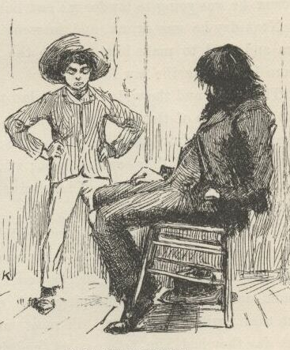
"All right. I'll ask him; and I'll make him pungle,
too, or I'll know the reason why. Say, how much
you got in your pocket? I want it."
"I hain't got only a dollar, and I want that to --"
"It don't make no difference what you want it for
-- you just shell it out."
He took it and bit it to see if it was good, and then
he said he was going down town to get some whisky;
said he hadn't had a drink all day. When he had got
out on the shed he put his head in again, and cussed
me for putting on frills and trying to be better than
him; and when I reckoned he was gone he come back
and put his head in again, and told me to mind about
that school, because he was going to lay for me and
lick me if I didn't drop that.
Next day he was drunk, and he went to Judge
Thatcher's and bullyragged him, and tried to make
him give up the money; but he couldn't, and then he
swore he'd make the law force him.
The judge and the widow went to law to get the
court to take me away from him and let one of them
be my guardian; but it was a new judge that had just
come, and he didn't know the old man; so he said
courts mustn't interfere and separate families if they
could help it; said he'd druther not take a child away
from its father. So Judge Thatcher and the widow
had to quit on the business.
That pleased the old man till he couldn't rest. He
said he'd cowhide me till I was black and blue if I
didn't raise some money for him. I borrowed three
dollars from Judge Thatcher, and pap took it and got
drunk, and went a-blowing around and cussing and
whooping and carrying on; and he kept it up all over
town, with a tin pan, till most midnight; then they
jailed him, and next day they had him before court,
and jailed him again for a week. But he said HE was
satisfied; said he was boss of his son, and he'd make
it warm for HIM.
When he got out the new judge said he was a-going
to make a man of him. So he took him to his
own house, and dressed him up clean and nice, and
had him to breakfast and dinner and supper with the
family, and was just old pie to him, so to speak. And
after supper he talked to him about temperance and
such things till the old man cried, and said he'd been a
fool, and fooled away his life; but now he was a-going
to turn over a new leaf and be a man nobody wouldn't
be ashamed of, and he hoped the judge would help
him and not look down on him. The judge said he
could hug him for them words; so he cried, and his
wife she cried again; pap said he'd been a man that had
always been misunderstood before, and the judge said
he believed it. The old man said that what a man
wanted that was down was sympathy, and the judge
said it was so; so they cried again. And when it was
bedtime the old man rose up and held out his hand,
and says:
"Look at it, gentlemen and ladies all; take a-hold
of it; shake it. There's a hand that was the hand of
a hog; but it ain't so no more; it's the hand of a man
that's started in on a new life, and'll die before he'll
go back. You mark them words -- don't forget I said
them. It's a clean hand now; shake it -- don't be
afeard."
So they shook it, one after the other, all around, and
cried. The judge's wife she kissed it. Then the old
man he signed a pledge -- made his mark. The judge
said it was the holiest time on record, or something
like that. Then they tucked the old man into a beauti-
ful room, which was the spare room, and in the night
some time he got powerful thirsty and clumb out on to
the porch-roof and slid down a stanchion and traded his
new coat for a jug of forty-rod, and clumb back again
and had a good old time; and towards daylight he
crawled out again, drunk as a fiddler, and rolled off
the porch and broke his left arm in two places, and
was most froze to death when somebody found him
after sun-up. And when they come to look at that
spare room they had to take soundings before they
could navigate it.
The judge he felt kind of sore. He said he reckoned
a body could reform the old man with a shotgun,
maybe, but he didn't know no other way.
Based on this comment, what did the Judge think of Pap’s chances of changing into a better person?

CHAPTER 6
WELL, pretty soon the old man was up and around
again, and then he went for Judge Thatcher in
the courts to make him give up that money, and he
went for me, too, for not stopping school. He catched
me a couple of times and thrashed me, but I went to
school just the same, and dodged him or outrun him
most of the time. I didn't want to go to school much
before, but I reckoned I'd go now to spite pap. That
law trial was a slow business -- appeared like they
warn't ever going to get started on it; so every now
and then I'd borrow two or three dollars off of the
judge for him, to keep from getting a cowhiding.
Every time he got money he got drunk; and every
time he got drunk he raised Cain around town; and
every time he raised Cain he got jailed. He was just
suited -- this kind of thing was right in his line.
He got to hanging around the widow's too much
and so she told him at last that if he didn't quit using
around there she would make trouble for him. Well,
WASN'T he mad? He said he would show who was
Huck Finn's boss. So he watched out for me one day
in the spring, and catched me, and took me up the
river about three mile in a skiff, and crossed over to
the Illinois shore where it was woody and there warn't
no houses but an old log hut in a place where the
timber was so thick you couldn't find it if you didn't
know where it was.
He kept me with him all the time, and I never got a
chance to run off. We lived in that old cabin, and he
always locked the door and put the key under his head
nights. He had a gun which he had stole, I reckon,
and we fished and hunted, and that was what we lived
on. Every little while he locked me in and went down
to the store, three miles, to the ferry, and traded fish
and game for whisky, and fetched it home and got
drunk and had a good time, and licked me. The
widow she found out where I was by and by, and she
sent a man over to try to get hold of me; but pap
drove him off with the gun, and it warn't long after
that till I was used to being where I was, and liked
it -- all but the cowhide part.
It was kind of lazy and jolly, laying off comfortable
all day, smoking and fishing, and no books nor study.
Two months or more run along, and my clothes got to
be all rags and dirt, and I didn't see how I'd ever got
to like it so well at the widow's, where you had to
wash, and eat on a plate, and comb up, and go to bed
and get up regular, and be forever bothering over a
book, and have old Miss Watson pecking at you all the
time. I didn't want to go back no more. I had
stopped cussing, because the widow didn't like it; but
now I took to it again because pap hadn't no objec-
tions. It was pretty good times up in the woods
there, take it all around.
But by and by pap got too handy with his hick'ry,
and I couldn't stand it. I was all over welts. He got
to going away so much, too, and locking me in. Once
he locked me in and was gone three days. It was
dreadful lonesome. I judged he had got drowned,
and I wasn't ever going to get out any more. I was
scared. I made up my mind I would fix up some way
to leave there. I had tried to get out of that cabin
many a time, but I couldn't find no way. There
warn't a window to it big enough for a dog to get
through. I couldn't get up the chimbly; it was too
narrow. The door was thick, solid oak slabs. Pap
was pretty careful not to leave a knife or anything in
the cabin when he was away; I reckon I had hunted
the place over as much as a hundred times; well, I
was most all the time at it, because it was about the
only way to put in the time. But this time I found
something at last; I found an old rusty wood-saw
without any handle; it was laid in between a rafter
and the clapboards of the roof. I greased it up and
went to work. There was an old horse-blanket nailed
against the logs at the far end of the cabin behind the
table, to keep the wind from blowing through the
chinks and putting the candle out. I got under the
table and raised the blanket, and went to work to saw
a section of the big bottom log out -- big enough to
let me through. Well, it was a good long job, but I
was getting towards the end of it when I heard pap's
gun in the woods. I got rid of the signs of my work,
and dropped the blanket and hid my saw, and pretty
soon pap come in.
Pap warn't in a good humor -- so he was his natural
self. He said he was down town, and everything was
going wrong. His lawyer said he reckoned he would
win his lawsuit and get the money if they ever got
started on the trial; but then there was ways to put it
off a long time, and Judge Thatcher knowed how to do
it And he said people allowed there'd be another
trial to get me away from him and give me to the
widow for my guardian, and they guessed it would win
this time. This shook me up considerable, because I
didn't want to go back to the widow's any more and
be so cramped up and sivilized, as they called it.
Then the old man got to cussing, and cussed every-
thing and everybody he could think of, and then cussed
them all over again to make sure he hadn't skipped
any, and after that he polished off with a kind of a
general cuss all round, including a considerable parcel
of people which he didn't know the names of, and so
called them what's-his-name when he got to them, and
went right along with his cussing.
He said he would like to see the widow get me.
He said he would watch out, and if they tried to come
any such game on him he knowed of a place six or
seven mile off to stow me in, where they might hunt
till they dropped and they couldn't find me. That
made me pretty uneasy again, but only for a minute;
I reckoned I wouldn't stay on hand till he got that
chance.
The old man made me go to the skiff and fetch the
things he had got. There was a fifty-pound sack of
corn meal, and a side of bacon, ammunition, and a
four-gallon jug of whisky, and an old book and two
newspapers for wadding, besides some tow. I toted
up a load, and went back and set down on the bow of
the skiff to rest. I thought it all over, and I reckoned
I would walk off with the gun and some lines, and take
to the woods when I run away. I guessed I wouldn't
stay in one place, but just tramp right across the
country, mostly night times, and hunt and fish to keep
alive, and so get so far away that the old man nor the
widow couldn't ever find me any more. I judged I
would saw out and leave that night if pap got drunk
enough, and I reckoned he would. I got so full of it
I didn't notice how long I was staying till the old man
hollered and asked me whether I was asleep or
drownded.
I got the things all up to the cabin, and then it was
about dark. While I was cooking supper the old man
took a swig or two and got sort of warmed up, and
went to ripping again. He had been drunk over in
town, and laid in the gutter all night, and he was a
sight to look at. A body would a thought he was
Adam -- he was just all mud. Whenever his liquor
begun to work he most always went for the govment.
his time he says:
"Call this a govment! why, just look at it and see
what it's like. Here's the law a-standing ready to take
a man's son away from him -- a man's own son, which
he has had all the trouble and all the anxiety and all
the expense of raising. Yes, just as that man has got
that son raised at last, and ready to go to work and
begin to do suthin' for HIM and give him a rest, the law
up and goes for him. And they call THAT govment!
That ain't all, nuther. The law backs that old Judge
Thatcher up and helps him to keep me out o' my
property. Here's what the law does: The law takes a
man worth six thousand dollars and up'ards, and jams
him into an old trap of a cabin like this, and lets him
go round in clothes that ain't fitten for a hog. They
call that govment! A man can't get his rights in a
govment like this. Sometimes I've a mighty notion to
just leave the country for good and all. Yes, and I
TOLD 'em so; I told old Thatcher so to his face. Lots
of 'em heard me, and can tell what I said. Says I,
for two cents I'd leave the blamed country and never
come a-near it agin. Them's the very words. I says
look at my hat -- if you call it a hat -- but the lid
raises up and the rest of it goes down till it's below
my chin, and then it ain't rightly a hat at all, but more
like my head was shoved up through a jint o' stove-
pipe. Look at it, says I -- such a hat for me to wear
-- one of the wealthiest men in this town if I could git
my rights.
"Oh, yes, this is a wonderful govment, wonderful.
Why, looky here. There was a free negro there from
Ohio -- a mulatter, most as white as a white man. He
had the whitest shirt on you ever see, too, and the
shiniest hat; and there ain't a man in that town that's
got as fine clothes as what he had; and he had a gold
watch and chain, and a silver-headed cane -- the awful-
est old gray-headed nabob in the State. And what do
you think? They said he was a p'fessor in a college,
and could talk all kinds of languages, and knowed
everything. And that ain't the wust. They said he
could VOTE when he was at home. Well, that let me
out. Thinks I, what is the country a-coming to? It
was 'lection day, and I was just about to go and vote
myself if I warn't too drunk to get there; but when
they told me there was a State in this country where
they'd let that negro vote, I drawed out. I says I'll
never vote agin. Them's the very words I said; they
all heard me; and the country may rot for all me --
I'll never vote agin as long as I live. And to see the
cool way of that negro -- why, he wouldn't a give me
the road if I hadn't shoved him out o' the way. I
says to the people, why ain't this negro put up at
auction and sold? -- that's what I want to know. And
what do you reckon they said? Why, they said he
couldn't be sold till he'd been in the State six months,
and he hadn't been there that long yet. There, now --
that's a specimen. They call that a govment that can't
sell a free negro till he's been in the State six months.
Here's a govment that calls itself a govment, and lets
on to be a govment, and thinks it is a govment, and
yet's got to set stock-still for six whole months before
it can take a hold of a prowling, thieving, infernal,
white-shirted free negro, and --"
Pap was agoing on so he never noticed where his
old limber legs was taking him to, so he went head over
heels over the tub of salt pork and barked both shins,
and the rest of his speech was all the hottest kind of
language -- mostly hove at the negro and the gov-
ment, though he give the tub some, too, all along,
here and there. He hopped around the cabin con-
siderable, first on one leg and then on the other, hold-
ing first one shin and then the other one, and at last he
let out with his left foot all of a sudden and fetched
the tub a rattling kick. But it warn't good judgment,
because that was the boot that had a couple of his toes
leaking out of the front end of it; so now he raised a
howl that fairly made a body's hair raise, and down he
went in the dirt, and rolled there, and held his toes;
and the cussing he done then laid over anything he
had ever done previous. He said so his own self after-
wards. He had heard old Sowberry Hagan in his
best days, and he said it laid over him, too; but I
reckon that was sort of piling it on, maybe.
After supper pap took the jug, and said he had
enough whisky there for two drunks and one delirium
tremens. That was always his word. I judged he
would be blind drunk in about an hour, and then I
would steal the key, or saw myself out, one or t'other.
He drank and drank, and tumbled down on his
blankets by and by; but luck didn't run my way. He
didn't go sound asleep, but was uneasy. He groaned
and moaned and thrashed around this way and that for
a long time. At last I got so sleepy I couldn't keep
my eyes open all I could do, and so before I knowed
what I was about I was sound asleep, and the candle
burning.
I don't know how long I was asleep, but all of a
sudden there was an awful scream and I was up.
There was pap looking wild, and skipping around every
which way and yelling about snakes. He said they
was crawling up his legs; and then he would give a
jump and scream, and say one had bit him on the
cheek -- but I couldn't see no snakes. He started
and run round and round the cabin, hollering "Take
him off! take him off! he's biting me on the neck!"
I never see a man look so wild in the eyes. Pretty
soon he was all fagged out, and fell down panting;
then he rolled over and over wonderful fast, kicking
things every which way, and striking and grabbing at
the air with his hands, and screaming and saying there
was devils a-hold of him. He wore out by and by,
and laid still a while, moaning. Then he laid stiller,
and didn't make a sound. I could hear the owls and
the wolves away off in the woods, and it seemed terri-
ble still. He was laying over by the corner. By and
by he raised up part way and listened, with his head
to one side. He says, very low:
"Tramp -- tramp -- tramp; that's the dead; tramp
-- tramp -- tramp; they're coming after me; but I
won't go. Oh, they're here! don't touch me -- don't!
hands off -- they're cold; let go. Oh, let a poor devil
alone!"
Then he went down on all fours and crawled off,
begging them to let him alone, and he rolled himself
up in his blanket and wallowed in under the old pine
table, still a-begging; and then he went to crying. I
could hear him through the blanket.
By and by he rolled out and jumped up on his feet
looking wild, and he see me and went for me. He
chased me round and round the place with a clasp-
knife, calling me the Angel of Death, and saying he
would kill me, and then I couldn't come for him no
more. I begged, and told him I was only Huck; but
he laughed SUCH a screechy laugh, and roared and
cussed, and kept on chasing me up. Once when I
turned short and dodged under his arm he made a
grab and got me by the jacket between my shoulders,
and I thought I was gone; but I slid out of the jacket
quick as lightning, and saved myself. Pretty soon he
was all tired out, and dropped down with his back
against the door, and said he would rest a minute and
then kill me. He put his knife under him, and said
he would sleep and get strong, and then he would see
who was who.
So he dozed off pretty soon. By and by I got the
old split-bottom chair and clumb up as easy as I could,
not to make any noise, and got down the gun. I
slipped the ramrod down it to make sure it was loaded,
then I laid it across the turnip barrel, pointing
towards pap, and set down behind it to wait for him to
stir. And how slow and still the time did drag along.

CHAPTER 7
“Git up! What you 'bout?"
I opened my eyes and looked around, trying
to make out where I was. It was after sun-up, and I
had been sound asleep. Pap was standing over me
looking sourQand sick, too. He says:
"What you doin' with this gun?"
I judged he didn't know nothing about what he had
been doing, so I says:
"Somebody tried to get in, so I was laying for
him."
"Why didn't you roust me out?"
"Well, I tried to, but I couldn't; I couldn't budge
you."
"Well, all right. Don't stand there palavering all
day, but out with you and see if there's a fish on the
lines for breakfast. I'll be along in a minute."
He unlocked the door, and I cleared out up the
river-bank. I noticed some pieces of limbs and such
things floating down, and a sprinkling of bark; so I
knowed the river had begun to rise. I reckoned I
would have great times now if I was over at the town.
The June rise used to be always luck for me; because
as soon as that rise begins here comes cordwood float-
ing down, and pieces of log rafts -- sometimes a dozen
logs together; so all you have to do is to catch them
and sell them to the wood-yards and the sawmill.
I went along up the bank with one eye out for pap
and t'other one out for what the rise might fetch
along. Well, all at once here comes a canoe; just a
beauty, too, about thirteen or fourteen foot long,
riding high like a duck. I shot head-first off of the
bank like a frog, clothes and all on, and struck out for
the canoe. I just expected there'd be somebody lay-
ing down in it, because people often done that to fool
folks, and when a chap had pulled a skiff out most to
it they'd raise up and laugh at him. But it warn't so
this time. It was a drift-canoe sure enough, and I
clumb in and paddled her ashore. Thinks I, the old
man will be glad when he sees this -- she's worth ten
dollars. But when I got to shore pap wasn't in sight
yet, and as I was running her into a little creek like a
gully, all hung over with vines and willows, I struck
another idea: I judged I'd hide her good, and then,
'stead of taking to the woods when I run off, I'd go
down the river about fifty mile and camp in one place
for good, and not have such a rough time tramping on
foot.
It was pretty close to the shanty, and I thought I
heard the old man coming all the time; but I got her
hid; and then I out and looked around a bunch of
willows, and there was the old man down the path
a piece just drawing a bead on a bird with his gun. So
he hadn't seen anything.
When he got along I was hard at it taking up a
"trot" line. He abused me a little for being so slow;
but I told him I fell in the river, and that was what
made me so long. I knowed he would see I was wet,
and then he would be asking questions. We got five
catfish off the lines and went home.
While we laid off after breakfast to sleep up, both of
us being about wore out, I got to thinking that if I could
fix up some way to keep pap and the widow from trying
to follow me, it would be a certainer thing than trust-
ing to luck to get far enough off before they missed
me; you see, all kinds of things might happen. Well,
I didn't see no way for a while, but by and by pap
raised up a minute to drink another barrel of water,
and he says:
"Another time a man comes a-prowling round here
you roust me out, you hear? That man warn't here
for no good. I'd a shot him. Next time you roust
me out, you hear?"
Then he dropped down and went to sleep again; but
what he had been saying give me the very idea I
wanted. I says to myself, I can fix it now so nobody
won't think of following me.
About twelve o'clock we turned out and went along
up the bank. The river was coming up pretty fast,
and lots of driftwood going by on the rise. By and
by along comes part of a log raft -- nine logs fast
together. We went out with the skiff and towed it
ashore. Then we had dinner. Anybody but pap
would a waited and seen the day through, so as to
catch more stuff; but that warn't pap's style. Nine
logs was enough for one time; he must shove right
over to town and sell. So he locked me in and took
the skiff, and started off towing the raft about half-
past three. I judged he wouldn't come back that
night. I waited till I reckoned he had got a good
start; then I out with my saw, and went to work on
that log again. Before he was t'other side of the river
I was out of the hole; him and his raft was just a
speck on the water away off yonder.
I took the sack of corn meal and took it to where
the canoe was hid, and shoved the vines and branches
apart and put it in; then I done the same with the
side of bacon; then the whisky-jug. I took all the
coffee and sugar there was, and all the ammunition; I
took the wadding; I took the bucket and gourd; I
took a dipper and a tin cup, and my old saw and two
blankets, and the skillet and the coffee-pot. I took
fish-lines and matches and other things -- everything
that was worth a cent. I cleaned out the place. I
wanted an axe, but there wasn't any, only the one out
at the woodpile, and I knowed why I was going to leave
that. I fetched out the gun, and now I was done.
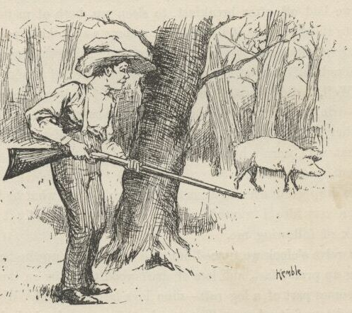
I had wore the ground a good deal crawling out of
the hole and dragging out so many things. So I
fixed that as good as I could from the outside by
scattering dust on the place, which covered up the
smoothness and the sawdust. Then I fixed the piece
of log back into its place, and put two rocks under it
and one against it to hold it there, for it was bent up
at that place and didn't quite touch ground. If you
stood four or five foot away and didn't know it was
sawed, you wouldn't never notice it; and besides, this
was the back of the cabin, and it warn't likely anybody
would go fooling around there.
It was all grass clear to the canoe, so I hadn't left a
track. I followed around to see. I stood on the
bank and looked out over the river. All safe. So I
took the gun and went up a piece into the woods, and
was hunting around for some birds when I see a wild
pig; hogs soon went wild in them bottoms after they
had got away from the prairie farms. I shot this fel-
low and took him into camp.
I took the axe and smashed in the door. I beat it
and hacked it considerable a-doing it. I fetched the
pig in, and took him back nearly to the table and
hacked into his throat with the axe, and laid him down
on the ground to bleed; I say ground because it was
ground -- hard packed, and no boards. Well, next I
took an old sack and put a lot of big rocks in it -- all I
could drag -- and I started it from the pig, and dragged
it to the door and through the woods down to the river
and dumped it in, and down it sunk, out of sight.
You could easy see that something had been dragged
over the ground. I did wish Tom Sawyer was there;
I knowed he would take an interest in this kind of
business, and throw in the fancy touches. Nobody
could spread himself like Tom Sawyer in such a thing
as that.
Well, last I pulled out some of my hair, and blooded
the axe good, and stuck it on the back side, and slung
the axe in the corner. Then I took up the pig and held
him to my breast with my jacket (so he couldn't drip)
till I got a good piece below the house and then
dumped him into the river. Now I thought of some-
thing else. So I went and got the bag of meal
and my old saw out of the canoe, and fetched
them to the house. I took the bag to where it
used to stand, and ripped a hole in the bottom of it
with the saw, for there warn't no knives and forks on
the place -- pap done everything with his clasp-knife
about the cooking. Then I carried the sack about a
hundred yards across the grass and through the willows
east of the house, to a shallow lake that was five mile
wide and full of rushes -- and ducks too, you might
say, in the season. There was a slough or a creek
leading out of it on the other side that went miles away,
I don't know where, but it didn't go to the river. The
meal sifted out and made a little track all the way to
the lake. I dropped pap's whetstone there too, so as
to look like it had been done by accident. Then I tied
up the rip in the meal sack with a string, so it wouldn't
leak no more, and took it and my saw to the canoe
again.
Summarize Huck’s list of things he did to fake his death so it was believable:
It was about dark now; so I dropped the canoe
down the river under some willows that hung over the
bank, and waited for the moon to rise. I made fast to
a willow; then I took a bite to eat, and by and by laid
down in the canoe to smoke a pipe and lay out a plan.
I says to myself, they'll follow the track of that sack-
ful of rocks to the shore and then drag the river for
me. And they'll follow that meal track to the lake
and go browsing down the creek that leads out of it to
find the robbers that killed me and took the things.
They won't ever hunt the river for anything but my
dead carcass. They'll soon get tired of that, and
won't bother no more about me. All right; I can
stop anywhere I want to. Jackson's Island is good
enough for me; I know that island pretty well, and
nobody ever comes there. And then I can paddle
over to town nights, and slink around and pick up
things I want. Jackson's Island's the place.
What exactly does it mean to “drag the river”?
I was pretty tired, and the first thing I knowed I
was asleep. When I woke up I didn't know where I
was for a minute. I set up and looked around, a little
scared. Then I remembered. The river looked miles
and miles across. The moon was so bright I could a
counted the drift logs that went a-slipping along, black
and still, hundreds of yards out from shore. Every-
thing was dead quiet, and it looked late, and SMELT
late. You know what I mean -- I don't know the
words to put it in.
I took a good gap and a stretch, and was just going
to unhitch and start when I heard a sound away over
the water. I listened. Pretty soon I made it out. It
was that dull kind of a regular sound that comes from
oars working in rowlocks when it's a still night. I
peeped out through the willow branches, and there it
was -- a skiff, away across the water. I couldn't tell
how many was in it. It kept a-coming, and when it
was abreast of me I see there warn't but one man in it.
Think's I, maybe it's pap, though I warn't expecting
him. He dropped below me with the current, and
by and by he came a-swinging up shore in the easy
water, and he went by so close I could a reached out
the gun and touched him. Well, it WAS pap, sure
enough -- and sober, too, by the way he laid his oars.
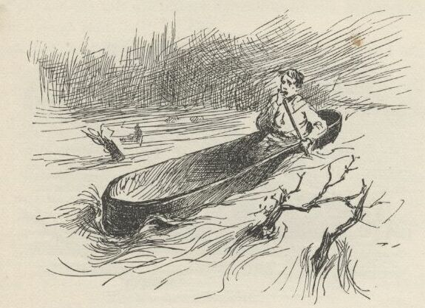
I didn't lose no time. The next minute I was a-
spinning down stream soft but quick in the shade of
the bank. I made two mile and a half, and then
struck out a quarter of a mile or more towards the
middle of the river, because pretty soon I would be
passing the ferry landing, and people might see me
and hail me. I got out amongst the driftwood, and
then laid down in the bottom of the canoe and let her
float. I laid there, and had a good rest and a smoke
out of my pipe, looking away into the sky; not a
cloud in it. The sky looks ever so deep when you lay
down on your back in the moonshine; I never knowed
it before. And how far a body can hear on the water
such nights! I heard people talking at the ferry land-
ing. I heard what they said, too -- every word of it.
One man said it was getting towards the long days and
the short nights now. T'other one said THIS warn't
one of the short ones, he reckoned -- and then they
laughed, and he said it over again, and they laughed
again; then they waked up another fellow and told
him, and laughed, but he didn't laugh; he ripped out
something brisk, and said let him alone. The first
fellow said he 'lowed to tell it to his old woman -- she
would think it was pretty good; but he said that
warn't nothing to some things he had said in his time.
I heard one man say it was nearly three o'clock, and
he hoped daylight wouldn't wait more than about a
week longer. After that the talk got further and
further away, and I couldn't make out the words any
more; but I could hear the mumble, and now and then
a laugh, too, but it seemed a long ways off.
I was away below the ferry now. I rose up, and
there was Jackson's Island, about two mile and a half
down stream, heavy timbered and standing up out of
the middle of the river, big and dark and solid, like a
steamboat without any lights. There warn't any signs
of the bar at the head -- it was all under water now.
In Huck’s day, what exactly was a river ferry?
It didn't take me long to get there. I shot past the
head at a ripping rate, the current was so swift, and
then I got into the dead water and landed on the side
towards the Illinois shore. I run the canoe into a deep
dent in the bank that I knowed about; I had to part
the willow branches to get in; and when I made fast
nobody could a seen the canoe from the outside.
I went up and set down on a log at the head of the
island, and looked out on the big river and the black
driftwood and away over to the town, three mile
away, where there was three or four lights twinkling.
A monstrous big lumber-raft was about a mile up
stream, coming along down, with a lantern in the
middle of it. I watched it come creeping down, and
when it was most abreast of where I stood I heard a
man say, "Stern oars, there! heave her head to stab-
board!" I heard that just as plain as if the man was
by my side.
There was a little gray in the sky now; so I stepped
into the woods, and laid down for a nap before break-
fast.

CHAPTER 8
THE sun was up so high when I waked that I judged
it was after eight o'clock. I laid there in the
grass and the cool shade thinking about things, and
feeling rested and ruther comfortable and satisfied. I
could see the sun out at one or two holes, but mostly
it was big trees all about, and gloomy in there amongst
them. There was freckled places on the ground where
the light sifted down through the leaves, and the
freckled places swapped about a little, showing there
was a little breeze up there. A couple of squirrels set
on a limb and jabbered at me very friendly.
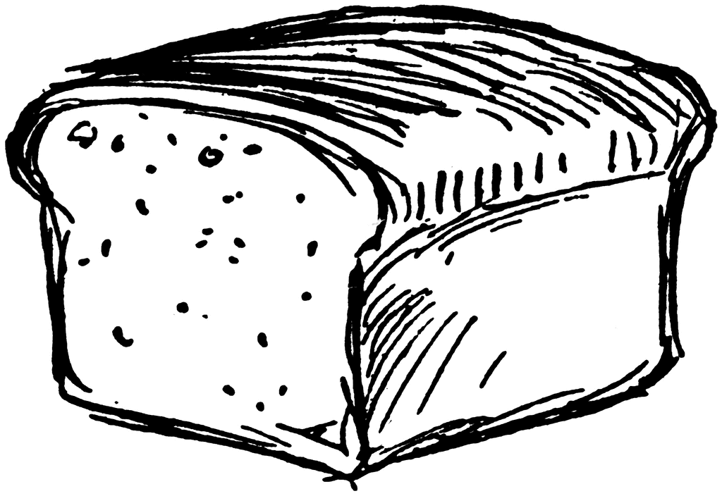
I was powerful lazy and comfortable -- didn't want
to get up and cook breakfast. Well, I was dozing off
again when I thinks I hears a deep sound of "boom!"
away up the river. I rouses up, and rests on my elbow
and listens; pretty soon I hears it again. I hopped
up, and went and looked out at a hole in the leaves,
and I see a bunch of smoke laying on the water a long
ways up -- about abreast the ferry. And there was
the ferryboat full of people floating along down. I
knowed what was the matter now. "Boom!" I see
the white smoke squirt out of the ferryboat's side.
You see, they was firing cannon over the water, trying
to make my carcass come to the top.
I was pretty hungry, but it warn't going to do for
me to start a fire, because they might see the smoke.
So I set there and watched the cannon-smoke and
listened to the boom. The river was a mile wide there,
and it always looks pretty on a summer morning -- so
I was having a good enough time seeing them hunt for
my remainders if I only had a bite to eat. Well, then
I happened to think how they always put quicksilver
in loaves of bread and float them off, because they
always go right to the drownded carcass and stop
there. So, says I, I'll keep a lookout, and if any of
them's floating around after me I'll give them a show.
I changed to the Illinois edge of the island to see what
luck I could have, and I warn't disappointed. A big
double loaf come along, and I most got it with a long
stick, but my foot slipped and she floated out further.
Of course I was where the current set in the closest to
the shore -- I knowed enough for that. But by and
by along comes another one, and this time I won. I
took out the plug and shook out the little dab of quick-
silver, and set my teeth in. It was "baker's bread"
-- what the quality eat; none of your low-down
corn-pone.
What is quicksilver?
Look up and then explain: What exactly was the logic behind floating loaves of bread and shooting cannonballs?
I got a good place amongst the leaves, and set there
on a log, munching the bread and watching the ferry-
boat, and very well satisfied. And then something
struck me. I says, now I reckon the widow or the
parson or somebody prayed that this bread would find
me, and here it has gone and done it. So there ain't
no doubt but there is something in that thing -- that is,
there's something in it when a body like the widow or
the parson prays, but it don't work for me, and I
reckon it don't work for only just the right kind.
I lit a pipe and had a good long smoke, and went
on watching. The ferryboat was floating with the
current, and I allowed I'd have a chance to see who
was aboard when she come along, because she would
come in close, where the bread did. When she'd got
pretty well along down towards me, I put out my pipe
and went to where I fished out the bread, and laid
down behind a log on the bank in a little open place.
Where the log forked I could peep through.
By and by she come along, and she drifted in so
close that they could a run out a plank and walked
ashore. Most everybody was on the boat. Pap, and
Judge Thatcher, and Bessie Thatcher, and Jo Harper,
and Tom Sawyer, and his old Aunt Polly, and Sid and
Mary, and plenty more. Everybody was talking about
the murder, but the captain broke in and says:
"Look sharp, now; the current sets in the closest
here, and maybe he's washed ashore and got tangled
amongst the brush at the water's edge. I hope so,
anyway."
"I didn't hope so. They all crowded up and leaned
over the rails, nearly in my face, and kept still, watch-
ing with all their might. I could see them first-rate,
but they couldn't see me. Then the captain sung out:
"Stand away!" and the cannon let off such a blast
right before me that it made me deef with the noise and
pretty near blind with the smoke, and I judged I was
gone. If they'd a had some bullets in, I reckon
they'd a got the corpse they was after. Well, I see I
warn't hurt, thanks to goodness. The boat floated on
and went out of sight around the shoulder of the island.
I could hear the booming now and then, further and
further off, and by and by, after an hour, I didn't hear
it no more. The island was three mile long. I judged
they had got to the foot, and was giving it up. But
they didn't yet a while. They turned around the foot
of the island and started up the channel on the Mis-
souri side, under steam, and booming once in a while
as they went. I crossed over to that side and watched
them. When they got abreast the head of the island
they quit shooting and dropped over to the Missouri
shore and went home to the town.
I knowed I was all right now. Nobody else would
come a-hunting after me. I got my traps out of the
canoe and made me a nice camp in the thick woods. I
made a kind of a tent out of my blankets to put my
things under so the rain couldn't get at them. I
catched a catfish and haggled him open with my saw,
and towards sundown I started my camp fire and had
supper. Then I set out a line to catch some fish for
breakfast.
When it was dark I set by my camp fire smoking,
and feeling pretty well satisfied; but by and by it got
sort of lonesome, and so I went and set on the bank
and listened to the current swashing along, and counted
the stars and drift logs and rafts that come down, and
then went to bed; there ain't no better way to put in
time when you are lonesome; you can't stay so, you
soon get over it.
And so for three days and nights. No difference --
just the same thing. But the next day I went explor-
ing around down through the island. I was boss of it;
it all belonged to me, so to say, and I wanted to know
all about it; but mainly I wanted to put in the time.
I found plenty strawberries, ripe and prime; and green
summer grapes, and green razberries; and the green
blackberries was just beginning to show. They would
all come handy by and by, I judged.
Well, I went fooling along in the deep woods till I
judged I warn't far from the foot of the island. I had
my gun along, but I hadn't shot nothing; it was for
protection; thought I would kill some game nigh
home. About this time I mighty near stepped on a
good-sized snake, and it went sliding off through the
grass and flowers, and I after it, trying to get a shot at
it. I clipped along, and all of a sudden I bounded
right on to the ashes of a camp fire that was still
smoking.
My heart jumped up amongst my lungs. I never
waited for to look further, but uncocked my gun and
went sneaking back on my tiptoes as fast as ever I
could. Every now and then I stopped a second amongst
the thick leaves and listened, but my breath come so
hard I couldn't hear nothing else. I slunk along an-
other piece further, then listened again; and so on,
and so on. If I see a stump, I took it for a man; if I
trod on a stick and broke it, it made me feel like a
person had cut one of my breaths in two and I only
got half, and the short half, too.
When I got to camp I warn't feeling very brash,
there warn't much sand in my craw; but I says, this
ain't no time to be fooling around. So I got all my
traps into my canoe again so as to have them out of
sight, and I put out the fire and scattered the ashes
around to look like an old last year's camp, and then
clumb a tree.
I reckon I was up in the tree two hours; but I
didn't see nothing, I didn't hear nothing -- I only
THOUGHT I heard and seen as much as a thousand
things. Well, I couldn't stay up there forever; so at
last I got down, but I kept in the thick woods and on
the lookout all the time. All I could get to eat was
berries and what was left over from breakfast.
By the time it was night I was pretty hungry. So
when it was good and dark I slid out from shore before
moonrise and paddled over to the Illinois bank -- about
a quarter of a mile. I went out in the woods and
cooked a supper, and I had about made up my mind
I would stay there all night when I hear a PLUNKETY-
PLUNK, PLUNKETY-PLUNK, and says to myself, horses
coming; and next I hear people's voices. I got
everything into the canoe as quick as I could, and then
went creeping through the woods to see what I could
find out. I hadn't got far when I hear a man say:
"We better camp here if we can find a good place;
the horses is about beat out. Let's look around."
I didn't wait, but shoved out and paddled away
easy. I tied up in the old place, and reckoned I would
sleep in the canoe.
I didn't sleep much. I couldn't, somehow, for
thinking. And every time I waked up I thought
somebody had me by the neck. So the sleep didn't
do me no good. By and by I says to myself, I can't
live this way; I'm a-going to find out who it is that's
here on the island with me; I'll find it out or bust.
Well, I felt better right off.
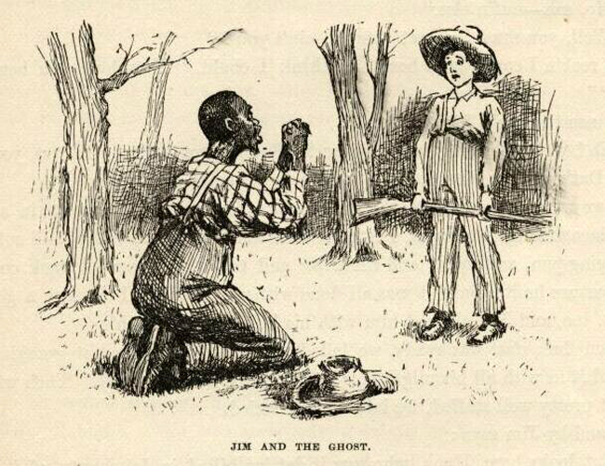
So I took my paddle and slid out from shore just a
step or two, and then let the canoe drop along down
amongst the shadows. The moon was shining, and out-
side of the shadows it made it most as light as day. I
poked along well on to an hour, everything still as
rocks and sound asleep. Well, by this time I was
most down to the foot of the island. A little ripply,
cool breeze begun to blow, and that was as good as
saying the night was about done. I give her a turn
with the paddle and brung her nose to shore; then I
got my gun and slipped out and into the edge of the
woods. I sat down there on a log, and looked out
through the leaves. I see the moon go off watch, and
the darkness begin to blanket the river. But in a little
while I see a pale streak over the treetops, and knowed
the day was coming. So I took my gun and slipped
off towards where I had run across that camp fire,
stopping every minute or two to listen. But I hadn't
no luck somehow; I couldn't seem to find the place.
But by and by, sure enough, I catched a glimpse of
fire away through the trees. I went for it, cautious
and slow. By and by I was close enough to have a
look, and there laid a man on the ground. It most
give me the fantods. He had a blanket around his
head, and his head was nearly in the fire. I set there
behind a clump of bushes in about six foot of him,
and kept my eyes on him steady. It was getting gray
daylight now. Pretty soon he gapped and stretched
himself and hove off the blanket, and it was Miss
Watson's Jim! I bet I was glad to see him. I says:
"Hello, Jim!" and skipped out.
He bounced up and stared at me wild. Then he
drops down on his knees, and puts his hands together
and says:
"Doan' hurt me -- don't! I hain't ever done no
harm to a ghos'. I alwuz liked dead people, en done
all I could for 'em. You go en git in de river agin,
whah you b'longs, en doan' do nuffn to Ole Jim, 'at
'uz awluz yo' fren'."
What does Jim think he sees when he encounters Huck?
Well, I warn't long making him understand I warn't
dead. I was ever so glad to see Jim. I warn't lone-
some now. I told him I warn't afraid of HIM telling
the people where I was. I talked along, but he only
set there and looked at me; never said nothing. Then
I says:
"It's good daylight. Le's get breakfast. Make up
your camp fire good."
"What's de use er makin' up de camp fire to cook
strawbries en sich truck? But you got a gun, hain't
you? Den we kin git sumfn better den strawbries."
"Strawberries and such truck," I says. "Is that
what you live on?"
"I couldn' git nuffn else," he says.
"Why, how long you been on the island, Jim?"
"I come heah de night arter you's killed."
"What, all that time?"
"Yes -- indeedy."
"And ain't you had nothing but that kind of rub-
bage to eat?"
"No, sah -- nuffn else."
"Well, you must be most starved, ain't you?"
"I reck'n I could eat a hoss. I think I could.
How long you ben on de islan'?"
"Since the night I got killed."
"No! W'y, what has you lived on? But you got
a gun. Oh, yes, you got a gun. Dat's good. Now
you kill sumfn en I'll make up de fire."
So we went over to where the canoe was, and while
he built a fire in a grassy open place amongst the trees,
I fetched meal and bacon and coffee, and coffee-pot
and frying-pan, and sugar and tin cups, and the negro
was set back considerable, because he reckoned it was
all done with witchcraft. I catched a good big catfish,
too, and Jim cleaned him with his knife, and fried
him.
When breakfast was ready we lolled on the grass and
eat it smoking hot. Jim laid it in with all his might,
for he was most about starved. Then when we had
got pretty well stuffed, we laid off and lazied.
By and by Jim says:
"But looky here, Huck, who wuz it dat 'uz killed
in dat shanty ef it warn't you?"
Then I told him the whole thing, and he said it was
smart. He said Tom Sawyer couldn't get up no better
plan than what I had. Then I says:
"How do you come to be here, Jim, and how'd you
get here?"
He looked pretty uneasy, and didn't say nothing for
a minute. Then he says:
"Maybe I better not tell."
"Why, Jim?"
"Well, dey's reasons. But you wouldn' tell on me
ef I uz to tell you, would you, Huck?"
"Blamed if I would, Jim."
"Well, I b'lieve you, Huck. I -- I RUN OFF."
"Jim!"
"But mind, you said you wouldn' tell -- you know
you said you wouldn' tell, Huck."
"Well, I did. I said I wouldn't, and I'll stick to it.
Honest INJUN, I will. People would call me a low-
down Abolitionist and despise me for keeping mum --
but that don't make no difference. I ain't a-going to
tell, and I ain't a-going back there, anyways. So,
now, le's know all about it."
"Well, you see, it 'uz dis way. Ole missus -- dat's
Miss Watson -- she pecks on me all de time, en treats
me pooty rough, but she awluz said she wouldn' sell
me down to Orleans. But I noticed dey wuz a negro
trader roun' de place considable lately, en I begin to
git oneasy. Well, one night I creeps to de do' pooty
late, en de do' warn't quite shet, en I hear old missus
tell de widder she gwyne to sell me down to Orleans,
but she didn' want to, but she could git eight hund'd
dollars for me, en it 'uz sich a big stack o' money she
couldn' resis'. De widder she try to git her to say
she wouldn' do it, but I never waited to hear de res'.
I lit out mighty quick, I tell you.
"I tuck out en shin down de hill, en 'spec to steal a
skift 'long de sho' som'ers 'bove de town, but dey wuz
people a-stirring yit, so I hid in de ole tumble-down
cooper-shop on de bank to wait for everybody to go
'way. Well, I wuz dah all night. Dey wuz somebody
roun' all de time. 'Long 'bout six in de mawnin'
skifts begin to go by, en 'bout eight er nine every
skift dat went 'long wuz talkin' 'bout how yo' pap
come over to de town en say you's killed. Dese las'
skifts wuz full o' ladies en genlmen a-goin' over for to
see de place. Sometimes dey'd pull up at de sho' en
take a res' b'fo' dey started acrost, so by de talk I got
to know all 'bout de killin'. I 'uz powerful sorry
you's killed, Huck, but I ain't no mo' now.
"I laid dah under de shavin's all day. I 'uz
hungry, but I warn't afeard; bekase I knowed ole
missus en de widder wuz goin' to start to de camp-
meet'n' right arter breakfas' en be gone all day, en
dey knows I goes off wid de cattle 'bout daylight, so
dey wouldn' 'spec to see me roun' de place, en so dey
wouldn' miss me tell arter dark in de evenin'. De
yuther servants wouldn' miss me, kase dey'd shin out
en take holiday soon as de ole folks 'uz out'n de way.
"Well, when it come dark I tuck out up de river
road, en went 'bout two mile er more to whah dey
warn't no houses. I'd made up my mine 'bout what
I's agwyne to do. You see, ef I kep' on tryin' to git
away afoot, de dogs 'ud track me; ef I stole a skift to
cross over, dey'd miss dat skift, you see, en dey'd
know 'bout whah I'd lan' on de yuther side, en whah
to pick up my track. So I says, a raff is what I's
arter; it doan' MAKE no track.
"I see a light a-comin' roun' de p'int bymeby, so I
wade' in en shove' a log ahead o' me en swum more'n
half way acrost de river, en got in 'mongst de drift-
wood, en kep' my head down low, en kinder swum
agin de current tell de raff come along. Den I swum
to de stern uv it en tuck a-holt. It clouded up en 'uz
pooty dark for a little while. So I clumb up en laid
down on de planks. De men 'uz all 'way yonder in
de middle, whah de lantern wuz. De river wuz a-
risin', en dey wuz a good current; so I reck'n'd 'at
by fo' in de mawnin' I'd be twenty-five mile down de
river, en den I'd slip in jis b'fo' daylight en swim
asho', en take to de woods on de Illinois side.
"But I didn' have no luck. When we 'uz mos'
down to de head er de islan' a man begin to come aft
wid de lantern, I see it warn't no use fer to wait, so I
slid overboard en struck out fer de islan'. Well, I had
a notion I could lan' mos' anywhers, but I couldn't --
bank too bluff. I 'uz mos' to de foot er de islan'
b'fo' I found' a good place. I went into de woods en
jedged I wouldn' fool wid raffs no mo', long as dey
move de lantern roun' so. I had my pipe en a plug er
dog-leg, en some matches in my cap, en dey warn't
wet, so I 'uz all right."
"And so you ain't had no meat nor bread to eat all
this time? Why didn't you get mud-turkles?"
"How you gwyne to git 'm? You can't slip up on
um en grab um; en how's a body gwyne to hit um
wid a rock? How could a body do it in de night?
En I warn't gwyne to show mysef on de bank in de
daytime."
"Well, that's so. You've had to keep in the woods
all the time, of course. Did you hear 'em shooting
the cannon?"
"Oh, yes. I knowed dey was arter you. I see um
go by heah -- watched um thoo de bushes."
Some young birds come along, flying a yard or two
at a time and lighting. Jim said it was a sign it was
going to rain. He said it was a sign when young
chickens flew that way, and so he reckoned it was the
same way when young birds done it. I was going to
catch some of them, but Jim wouldn't let me. He
said it was death. He said his father laid mighty sick
once, and some of them catched a bird, and his old
granny said his father would die, and he did.
And Jim said you mustn't count the things you are
going to cook for dinner, because that would bring
bad luck. The same if you shook the table-cloth after
sundown. And he said if a man owned a beehive and
that man died, the bees must be told about it before
sun-up next morning, or else the bees would all
weaken down and quit work and die. Jim said bees
wouldn't sting idiots; but I didn't believe that, be-
cause I had tried them lots of times myself, and they
wouldn't sting me.
What are 2 more examples of luck and superstition seen in the story? What are 2 superstitions you have heard as a kid that are not in the book?
I had heard about some of these things before, but
not all of them. Jim knowed all kinds of signs. He
said he knowed most everything. I said it looked to
me like all the signs was about bad luck, and so I
asked him if there warn't any good-luck signs. He
says:
"Mighty few -- an' DEY ain't no use to a body.
What you want to know when good luck's a-comin'
for? Want to keep it off?" And he said: "Ef you's
got hairy arms en a hairy breas', it's a sign dat you's
agwyne to be rich. Well, dey's some use in a sign
like dat, 'kase it's so fur ahead. You see, maybe
you's got to be po' a long time fust, en so you might
git discourage' en kill yo'sef 'f you didn' know by de
sign dat you gwyne to be rich bymeby."
"Have you got hairy arms and a hairy breast,
Jim?"
"What's de use to ax dat question? Don't you
see I has?"
"Well, are you rich?"
"No, but I ben rich wunst, and gwyne to be rich
agin. Wunst I had foteen dollars, but I tuck to
specalat'n', en got busted out."
"What did you speculate in, Jim?"
"Well, fust I tackled stock."
"What kind of stock?"
"Why, live stock -- cattle, you know. I put ten
dollars in a cow. But I ain' gwyne to resk no mo'
money in stock. De cow up 'n' died on my han's."
"So you lost the ten dollars."
"No, I didn't lose it all. I on'y los' 'bout nine of
it. I sole de hide en taller for a dollar en ten cents."
"You had five dollars and ten cents left. Did you
speculate any more?"
"Yes. You know that one-laigged negro dat
b'longs to old Misto Bradish? Well, he sot up a
bank, en say anybody dat put in a dollar would git fo'
dollars mo' at de en' er de year. Well, all de negros
went in, but dey didn't have much. I wuz de on'y
one dat had much. So I stuck out for mo' dan fo'
dollars, en I said 'f I didn' git it I'd start a bank my-
sef. Well, o' course dat negro want' to keep me out
er de business, bekase he says dey warn't business
'nough for two banks, so he say I could put in my five
dollars en he pay me thirty-five at de en' er de year.
"So I done it. Den I reck'n'd I'd inves' de
thirty-five dollars right off en keep things a-movin'.
Dey wuz a negro name' Bob, dat had ketched a wood-
flat, en his marster didn' know it; en I bought it off'n
him en told him to take de thirty-five dollars when de
en' er de year come; but somebody stole de wood-flat
dat night, en nex day de one-laigged negro say de
bank's busted. So dey didn' none uv us git no
money."
"What did you do with the ten cents, Jim?"
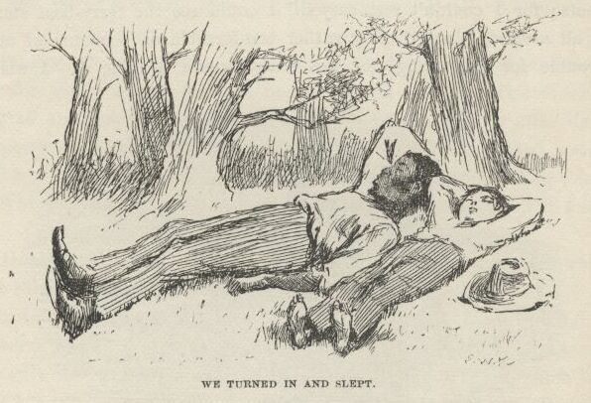
"Well, I 'uz gwyne to spen' it, but I had a dream,
en de dream tole me to give it to a negro name'
Balum -- Balum's Ass dey call him for short; he's
one er dem chuckleheads, you know. But he's lucky,
dey say, en I see I warn't lucky. De dream say let
Balum inves' de ten cents en he'd make a raise for me.
Well, Balum he tuck de money, en when he wuz in
church he hear de preacher say dat whoever give to de
po' len' to de Lord, en boun' to git his money back a
hund'd times. So Balum he tuck en give de ten cents
to de po', en laid low to see what wuz gwyne to come
of it."
"Well, what did come of it, Jim?"
"Nuffn never come of it. I couldn' manage to
k'leck dat money no way; en Balum he couldn'. I
ain' gwyne to len' no mo' money 'dout I see de
security. Boun' to git yo' money back a hund'd
times, de preacher says! Ef I could git de ten CENTS
back, I'd call it squah, en be glad er de chanst."
"Well, it's all right anyway, Jim, long as you're
going to be rich again some time or other."
"Yes; en I's rich now, come to look at it. I owns
mysef, en I's wuth eight hund'd dollars. I wisht I
had de money, I wouldn' want no mo'."
Why might Huck and Jim make good travel partners for this journey?
Why do you think Huck decides to help Jim run away?

