CHAPTER 15
WE judged that three nights more would fetch us to
Cairo, at the bottom of Illinois, where the Ohio
River comes in, and that was what we was after. We
would sell the raft and get on a steamboat and go way
up the Ohio amongst the free States, and then be out
of trouble.
In the mid-1800s, which states were considered free states? Make a list:
Well, the second night a fog begun to come on, and
we made for a towhead to tie to, for it wouldn't do to
try to run in a fog; but when I paddled ahead in the
canoe, with the line to make fast, there warn't any-
thing but little saplings to tie to. I passed the line
around one of them right on the edge of the cut bank,
but there was a stiff current, and the raft come boom-
ing down so lively she tore it out by the roots and
away she went. I see the fog closing down, and it
made me so sick and scared I couldn't budge for most
a half a minute it seemed to me -- and then there warn't
no raft in sight; you couldn't see twenty yards. I
jumped into the canoe and run back to the stern, and
grabbed the paddle and set her back a stroke. But
she didn't come. I was in such a hurry I hadn't
untied her. I got up and tried to untie her, but I was
so excited my hands shook so I couldn't hardly do
anything with them.
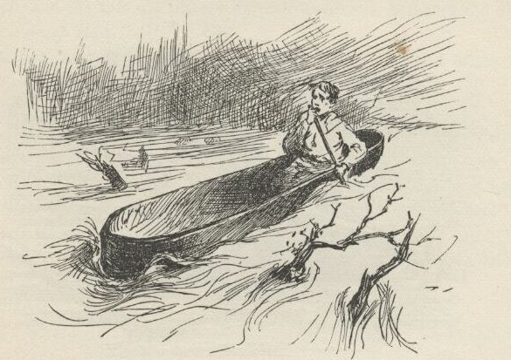
As soon as I got started I took out after the raft,
hot and heavy, right down the towhead. That was
all right as far as it went, but the towhead warn't
sixty yards long, and the minute I flew by the foot of
it I shot out into the solid white fog, and hadn't no
more idea which way I was going than a dead man.
Thinks I, it won't do to paddle; first I know I'll
run into the bank or a towhead or something; I got
to set still and float, and yet it's mighty fidgety busi-
ness to have to hold your hands still at such a time. I
whooped and listened. Away down there somewheres
I hears a small whoop, and up comes my spirits. I
went tearing after it, listening sharp to hear it again.
The next time it come I see I warn't heading for it,
but heading away to the right of it. And the next
time I was heading away to the left of it -- and not
gaining on it much either, for I was flying around, this
way and that and t'other, but it was going straight
ahead all the time.
I did wish the fool would think to beat a tin pan,
and beat it all the time, but he never did, and it was
the still places between the whoops that was making
the trouble for me. Well, I fought along, and directly
I hears the whoop BEHIND me. I was tangled good
now. That was somebody else's whoop, or else I was
turned around.
I throwed the paddle down. I heard the whoop
again; it was behind me yet, but in a different place;
it kept coming, and kept changing its place, and I kept
answering, till by and by it was in front of me again,
and I knowed the current had swung the canoe's head
down-stream, and I was all right if that was Jim and
not some other raftsman hollering. I couldn't tell
nothing about voices in a fog, for nothing don't look
natural nor sound natural in a fog.
The whooping went on, and in about a minute I
come a-booming down on a cut bank with smoky
ghosts of big trees on it, and the current throwed me
off to the left and shot by, amongst a lot of snags that
fairly roared, the currrent was tearing by them so swift.
In another second or two it was solid white and still
again. I set perfectly still then, listening to my heart
thump, and I reckon I didn't draw a breath while it
thumped a hundred.
I just give up then. I knowed what the matter was.
That cut bank was an island, and Jim had gone down
t'other side of it. It warn't no towhead that you
could float by in ten minutes. It had the big timber
of a regular island; it might be five or six miles long
and more than half a mile wide.
I kept quiet, with my ears cocked, about fifteen
minutes, I reckon. I was floating along, of course,
four or five miles an hour; but you don't ever think
of that. No, you FEEL like you are laying dead still on
the water; and if a little glimpse of a snag slips by
you don't think to yourself how fast YOU'RE going, but
you catch your breath and think, my! how that snag's
tearing along. If you think it ain't dismal and lone-
some out in a fog that way by yourself in the night,
you try it once -- you'll see.
Next, for about a half an hour, I whoops now and
then; at last I hears the answer a long ways off, and
tries to follow it, but I couldn't do it, and directly I
judged I'd got into a nest of towheads, for I had little
dim glimpses of them on both sides of me -- sometimes
just a narrow channel between, and some that I
couldn't see I knowed was there because I'd hear the
wash of the current against the old dead brush and
trash that hung over the banks. Well, I warn't long
loosing the whoops down amongst the towheads; and
I only tried to chase them a little while, anyway, be-
cause it was worse than chasing a Jack-o'-lantern.
You never knowed a sound dodge around so, and
swap places so quick and so much.
What is a towhead?
I had to claw away from the bank pretty lively four
or five times, to keep from knocking the islands out of
the river; and so I judged the raft must be butting
into the bank every now and then, or else it would get
further ahead and clear out of hearing -- it was floating
a little faster than what I was.
Well, I seemed to be in the open river again by and
by, but I couldn't hear no sign of a whoop nowheres.
I reckoned Jim had fetched up on a snag, maybe, and
it was all up with him. I was good and tired, so I laid
down in the canoe and said I wouldn't bother no
more. I didn't want to go to sleep, of course; but I
was so sleepy I couldn't help it; so I thought I would
take jest one little cat-nap.
But I reckon it was more than a cat-nap, for when I
waked up the stars was shining bright, the fog was all
gone, and I was spinning down a big bend stern first.
First I didn't know where I was; I thought I was
dreaming; and when things began to come back to me
they seemed to come up dim out of last week.
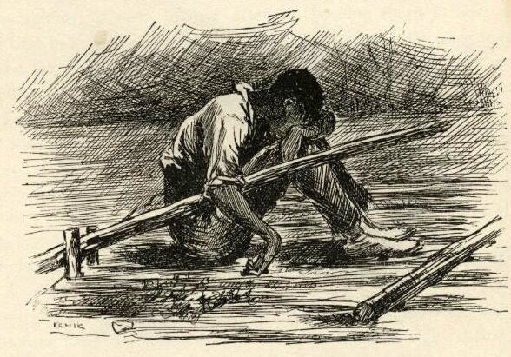
It was a monstrous big river here, with the tallest
and the thickest kind of timber on both banks; just a
solid wall, as well as I could see by the stars. I looked
away down-stream, and seen a black speck on the
water. I took after it; but when I got to it it warn't
nothing but a couple of sawlogs made fast together.
Then I see another speck, and chased that; then
another, and this time I was right. It was the raft.
When I got to it Jim was setting there with his head
down between his knees, asleep, with his right arm
hanging over the steering-oar. The other oar was
smashed off, and the raft was littered up with leaves
and branches and dirt. So she'd had a rough time.
I made fast and laid down under Jim's nose on the
raft, and began to gap, and stretch my fists out against
Jim, and says:
"Hello, Jim, have I been asleep? Why didn't you
stir me up?"
"Goodness gracious, is dat you, Huck? En you
ain' dead -- you ain' drownded -- you's back agin?
It's too good for true, honey, it's too good for true.
Lemme look at you chile, lemme feel o' you. No,
you ain' dead! you's back agin, 'live en soun', jis de
same ole Huck -- de same ole Huck, thanks to good-
ness!"
"What's the matter with you, Jim? You been a-
drinking?"
"Drinkin'? Has I ben a-drinkin'? Has I had a
chance to be a-drinkin'?"
"Well, then, what makes you talk so wild?"
"How does I talk wild?"
"HOW? Why, hain't you been talking about my
coming back, and all that stuff, as if I'd been gone
away?"
"Huck -- Huck Finn, you look me in de eye; look
me in de eye. HAIN'T you ben gone away?"
"Gone away? Why, what in the nation do you
mean? I hain't been gone anywheres. Where would
I go to?"
"Well, looky here, boss, dey's sumf'n wrong, dey
is. Is I ME, or who IS I? Is I heah, or whah IS I?
Now dat's what I wants to know."
"Well, I think you're here, plain enough, but I
think you're a tangle-headed old fool, Jim."
"I is, is I? Well, you answer me dis: Didn't you
tote out de line in de canoe fer to make fas' to de tow-
head?"
"No, I didn't. What tow-head? I hain't see no
tow-head."
"You hain't seen no towhead? Looky here, didn't
de line pull loose en de raf' go a-hummin' down de
river, en leave you en de canoe behine in de fog?"
"What fog?"
"Why, de fog! -- de fog dat's been aroun' all night.
En didn't you whoop, en didn't I whoop, tell we got
mix' up in de islands en one un us got los' en t'other
one was jis' as good as los', 'kase he didn' know whah
he wuz? En didn't I bust up agin a lot er dem islands
en have a turrible time en mos' git drownded? Now
ain' dat so, boss -- ain't it so? You answer me dat."
"Well, this is too many for me, Jim. I hain't seen
no fog, nor no islands, nor no troubles, nor nothing.
I been setting here talking with you all night till you
went to sleep about ten minutes ago, and I reckon I
done the same. You couldn't a got drunk in that
time, so of course you've been dreaming."
What prank is Huck trying to pull on Jim here?
"Dad fetch it, how is I gwyne to dream all dat in
ten minutes?"
"Well, hang it all, you did dream it, because there
didn't any of it happen."
"But, Huck, it's all jis' as plain to me as --"
"It don't make no difference how plain it is; there
ain't nothing in it. I know, because I've been here
all the time."
Jim didn't say nothing for about five minutes, but
set there studying over it. Then he says:
"Well, den, I reck'n I did dream it, Huck; but
dog my cats ef it ain't de powerfullest dream I ever
see. En I hain't ever had no dream b'fo' dat's tired
me like dis one."
"Oh, well, that's all right, because a dream does
tire a body like everything sometimes. But this one
was a staving dream; tell me all about it, Jim."
So Jim went to work and told me the whole thing
right through, just as it happened, only he painted it
up considerable. Then he said he must start in and
"'terpret" it, because it was sent for a warning. He
said the first towhead stood for a man that would try
to do us some good, but the current was another man
that would get us away from him. The whoops was
warnings that would come to us every now and then,
and if we didn't try hard to make out to understand
them they'd just take us into bad luck, 'stead of keep-
ing us out of it. The lot of towheads was troubles
we was going to get into with quarrelsome people and
all kinds of mean folks, but if we minded our business
and didn't talk back and aggravate them, we would
pull through and get out of the fog and into the big
clear river, which was the free States, and wouldn't
have no more trouble.
It had clouded up pretty dark just after I got on to
the raft, but it was clearing up again now.
"Oh, well, that's all interpreted well enough as far
as it goes, Jim," I says; "but what does THESE things
stand for?"
It was the leaves and rubbish on the raft and the
smashed oar. You could see them first-rate now.
Jim looked at the trash, and then looked at me, and
back at the trash again. He had got the dream fixed
so strong in his head that he couldn't seem to shake it
loose and get the facts back into its place again right
away. But when he did get the thing straightened
around he looked at me steady without ever smiling,
and says:
"What do dey stan' for? I'se gwyne to tell you.
When I got all wore out wid work, en wid de callin'
for you, en went to sleep, my heart wuz mos' broke
bekase you wuz los', en I didn' k'yer no' mo' what
become er me en de raf'. En when I wake up en fine
you back agin, all safe en soun', de tears come, en I
could a got down on my knees en kiss yo' foot, I's so
thankful. En all you wuz thinkin' 'bout wuz how you
could make a fool uv ole Jim wid a lie. Dat truck dah
is TRASH; en trash is what people is dat puts dirt on de
head er dey fren's en makes 'em ashamed."
Why does this joke make Jim upset? What does this teach Huck to realize about Jim?
Then he got up slow and walked to the wigwam,
and went in there without saying anything but that.
But that was enough. It made me feel so mean I
could almost kissed HIS foot to get him to take it back.
It was fifteen minutes before I could work myself up
to go and humble myself to a nigger; but I done it,
and I warn't ever sorry for it afterwards, neither. I
didn't do him no more mean tricks, and I wouldn't
done that one if I'd a knowed it would make him feel
that way.
Think about the time period and the culture of this novel. What is significant about what Huck did in this last paragraph—going and apologizing to Jim? What is Huckleberry realizing about Jim at this point in the book?

