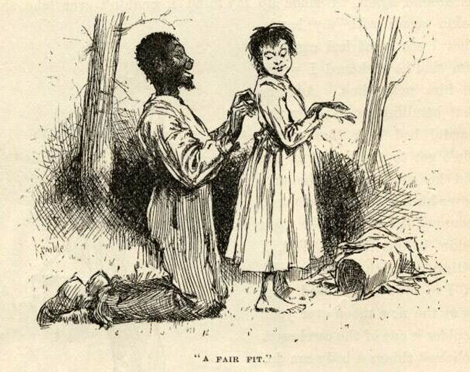
CHAPTER 11
"COME in," says the woman, and I did. She
says: "Take a cheer."
I done it. She looked me all over with her little
shiny eyes, and says:
"What might your name be?"
"Sarah Williams."
"Where 'bouts do you live? In this neighbor-
hood?'
"No'm. In Hookerville, seven mile below. I've
walked all the way and I'm all tired out."
"Hungry, too, I reckon. I'll find you something."
"No'm, I ain't hungry. I was so hungry I had to
stop two miles below here at a farm; so I ain't hungry
no more. It's what makes me so late. My mother's
down sick, and out of money and everything, and I
come to tell my uncle Abner Moore. He lives at the
upper end of the town, she says. I hain't ever been
here before. Do you know him?"
"No; but I don't know everybody yet. I haven't
lived here quite two weeks. It's a considerable ways
to the upper end of the town. You better stay here
all night. Take off your bonnet."
"No," I says; "I'll rest a while, I reckon, and go
on. I ain't afeared of the dark."
She said she wouldn't let me go by myself, but her
husband would be in by and by, maybe in a hour and
a half, and she'd send him along with me. Then she
got to talking about her husband, and about her rela-
tions up the river, and her relations down the river,
and about how much better off they used to was, and
how they didn't know but they'd made a mistake
coming to our town, instead of letting well alone --
and so on and so on, till I was afeard I had made a
mistake coming to her to find out what was going on
in the town; but by and by she dropped on to pap
and the murder, and then I was pretty willing to let
her clatter right along. She told about me and Tom
Sawyer finding the six thousand dollars (only she got
it ten) and all about pap and what a hard lot he was,
and what a hard lot I was, and at last she got down to
where I was murdered. I says:
"Who done it? We've heard considerable about
these goings on down in Hookerville, but we don't
know who 'twas that killed Huck Finn."
"Well, I reckon there's a right smart chance of
people HERE that'd like to know who killed him. Some
think old Finn done it himself."
"No -- is that so?"
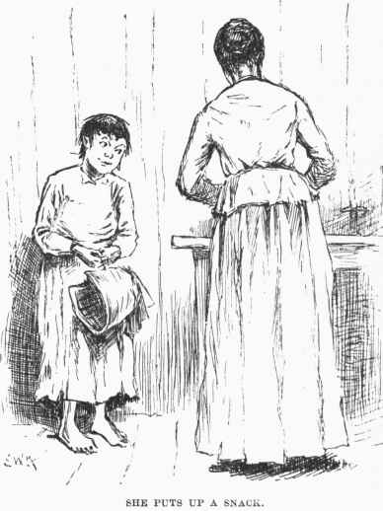
"Most everybody thought it at first. He'll never
know how nigh he come to getting lynched. But
before night they changed around and judged it was
done by a runaway slave named Jim."
"Why HE --"
I stopped. I reckoned I better keep still. She run
on, and never noticed I had put in at all:
"That slave run off the very night Huck Finn was
killed. So there's a reward out for him -- three hun-
dred dollars. And there's a reward out for old Finn,
too -- two hundred dollars. You see, he come to town
the morning after the murder, and told about it, and
was out with 'em on the ferryboat hunt, and right
away after he up and left. Before night they wanted
to lynch him, but he was gone, you see. Well, next
day they found out the slave was gone; they found
out he hadn't ben seen sence ten o'clock the night the
murder was done. So then they put it on him, you
see; and while they was full of it, next day, back
comes old Finn, and went boo-hooing to Judge
Thatcher to get money to hunt for the slave all over
Illinois with. The judge gave him some, and that
evening he got drunk, and was around till after mid-
night with a couple of mighty hard-looking strangers,
and then went off with them. Well, he hain't come
back sence, and they ain't looking for him back till
this thing blows over a little, for people thinks now
that he killed his boy and fixed things so folks would
think robbers done it, and then he'd get Huck's money
without having to bother a long time with a lawsuit.
People do say he warn't any too good to do it. Oh,
he's sly, I reckon. If he don't come back for a year
he'll be all right. You can't prove anything on him,
you know; everything will be quieted down then, and
he'll walk in Huck's money as easy as nothing."
"Yes, I reckon so, 'm. I don't see nothing in the
way of it. Has everybody guit thinking the slave Jim
done it?"
"Oh, no, not everybody. A good many thinks he
done it. But they'll get ‘im pretty soon now,
and maybe they can scare it out of him."
"Why, are they after him yet?"
"Well, you're innocent, ain't you! Does three
hundred dollars lay around every day for people to
pick up? Some folks think the runaway ain't far from
here. I'm one of them -- but I hain't talked it around.
A few days ago I was talking with an old couple that
lives next door in the log shanty, and they happened
to say hardly anybody ever goes to that island over
yonder that they call Jackson's Island. Don't any-
body live there? says I. No, nobody, says they. I
didn't say any more, but I done some thinking. I
was pretty near certain I'd seen smoke over there,
about the head of the island, a day or two before that,
so I says to myself, like as not that slave's hiding
over there; anyway, says I, it's worth the trouble to
give the place a hunt. I hain't seen any smoke sence,
so I reckon maybe he's gone, if it was him; but
husband's going over to see -- him and another man.
He was gone up the river; but he got back to-day,
and I told him as soon as he got here two hours ago."
Do a little web searching and find out about how much the modern day equivalent of $300 in 1850.
I had got so uneasy I couldn't set still. I had to do
something with my hands; so I took up a needle off of
the table and went to threading it. My hands shook,
and I was making a bad job of it. When the woman
stopped talking I looked up, and she was looking at
me pretty curious and smiling a little. I put down the
needle and thread, and let on to be interested -- and I
was, too -- and says:
"Three hundred dollars is a power of money. I
wish my mother could get it. Is your husband going
over there to-night?"
"Oh, yes. He went up-town with the man I was
telling you of, to get a boat and see if they could
borrow another gun. They'll go over after midnight."
"Couldn't they see better if they was to wait till
daytime?"
"Yes. And couldn't the runaway see better, too?
After midnight he'll likely be asleep, and they can slip
around through the woods and hunt up his camp fire
all the better for the dark, if he's got one."
"I didn't think of that."
The woman kept looking at me pretty curious, and
I didn't feel a bit comfortable. Pretty soon she says"
"What did you say your name was, honey?"
"M -- Mary Williams."
Somehow it didn't seem to me that I said it was
Mary before, so I didn't look up -- seemed to me I
said it was Sarah; so I felt sort of cornered, and was
afeared maybe I was looking it, too. I wished the
woman would say something more; the longer she set
still the uneasier I was. But now she says:
"Honey, I thought you said it was Sarah when
you first come in?"
"Oh, yes'm, I did. Sarah Mary Williams. Sarah's
my first name. Some calls me Sarah, some calls me
Mary."
"Oh, that's the way of it?"
"Yes'm."
I was feeling better then, but I wished I was out of
there, anyway. I couldn't look up yet.
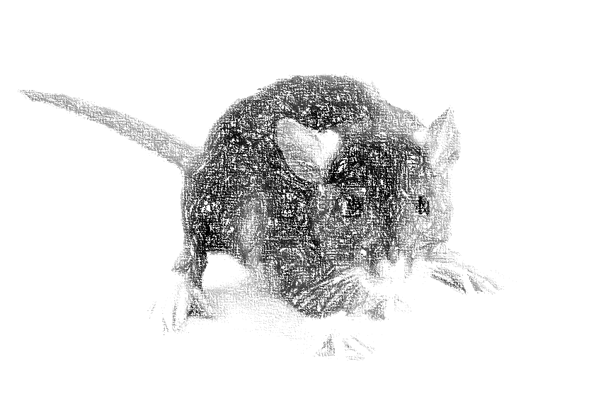
Well, the woman fell to talking about how hard
times was, and how poor they had to live, and how the
rats was as free as if they owned the place, and so
forth and so on, and then I got easy again. She was
right about the rats. You'd see one stick his nose out
of a hole in the corner every little while. She said she
had to have things handy to throw at them when she
was alone, or they wouldn't give her no peace. She
showed me a bar of lead twisted up into a knot, and
said she was a good shot with it generly, but she'd
wrenched her arm a day or two ago, and didn't know
whether she could throw true now. But she watched
for a chance, and directly banged away at a rat; but
she missed him wide, and said "Ouch!" it hurt her
arm so. Then she told me to try for the next one. I
wanted to be getting away before the old man got
back, but of course I didn't let on. I got the thing,
and the first rat that showed his nose I let drive, and
if he'd a stayed where he was he'd a been a tolerable
sick rat. She said that was first-rate, and she reckoned
I would hive the next one. She went and got the
lump of lead and fetched it back, and brought along a
hank of yarn which she wanted me to help her with.
I held up my two hands and she put the hank over
them, and went on talking about her and her husband's
matters. But she broke off to say:
"Keep your eye on the rats. You better have the
lead in your lap, handy."
So she dropped the lump into my lap just at that
moment, and I clapped my legs together on it and she
went on talking. But only about a minute. Then
she took off the hank and looked me straight in the
face, and very pleasant, and says:
"Come, now, what's your real name?"
"Wh -- what, mum?"
"What's your real name? Is it Bill, or Tom, or
Bob? -- or what is it?"
What three clues tipped the lady off that Huck was not a girl?
I reckon I shook like a leaf, and I didn't know
hardly what to do. But I says:
"Please to don't poke fun at a poor girl like me,
mum. If I'm in the way here, I'll --"
"No, you won't. Set down and stay where you
are. I ain't going to hurt you, and I ain't going to
tell on you, nuther. You just tell me your secret, and
trust me. I'll keep it; and, what's more, I'll help
you. So'll my old man if you want him to. You
see, you're a runaway 'prentice, that's all. It ain't
anything. There ain't no harm in it. You've been
treated bad, and you made up your mind to cut.
Bless you, child, I wouldn't tell on you. Tell me all
about it now, that's a good boy."
So I said it wouldn't be no use to try to play it any
longer, and I would just make a clean breast and tell
her everything, but she musn't go back on her promise.
Then I told her my father and mother was dead, and
the law had bound me out to a mean old farmer in the
country thirty mile back from the river, and he treated
me so bad I couldn't stand it no longer; he went away
to be gone a couple of days, and so I took my chance
and stole some of his daughter's old clothes and
cleared out, and I had been three nights coming the
thirty miles. I traveled nights, and hid daytimes and
slept, and the bag of bread and meat I carried from
home lasted me all the way, and I had a-plenty. I
said I believed my uncle Abner Moore would take care
of me, and so that was why I struck out for this town
of Goshen.
"Goshen, child? This ain't Goshen. This is St.
Petersburg. Goshen's ten mile further up the river.
Who told you this was Goshen?"
"Why, a man I met at daybreak this morning, just
as I was going to turn into the woods for my regular
sleep. He told me when the roads forked I must take
the right hand, and five mile would fetch me to
Goshen."
"He was drunk, I reckon. He told you just ex-
actly wrong."
"Well,,he did act like he was drunk, but it ain't no
matter now. I got to be moving along. I'll fetch
Goshen before daylight."
"Hold on a minute. I'll put you up a snack to eat.
You might want it."
So she put me up a snack, and says:
"Say, when a cow's laying down, which end of her
gets up first? Answer up prompt now -- don't stop
to study over it. Which end gets up first?"
What are 3 questions to ask someone to determine whether or not he had actually lived in Bowling Green?
1.

2.

3.

"The hind end, mum."
"Well, then, a horse?"
"The for'rard end, mum."
"Which side of a tree does the moss grow on?"
"North side."
"If fifteen cows is browsing on a hillside, how
many of them eats with their heads pointed the same
direction?"
"The whole fifteen, mum."
"Well, I reckon you HAVE lived in the country. I
thought maybe you was trying to hocus me again.
What's your real name, now?"
"George Peters, mum."
"Well, try to remember it, George. Don't forget
and tell me it's Elexander before you go, and then get
out by saying it's George Elexander when I catch you.
And don't go about women in that old calico. You
do a girl tolerable poor, but you might fool men,
maybe. Bless you, child, when you set out to thread
a needle don't hold the thread still and fetch the needle
up to it; hold the needle still and poke the thread at
it; that's the way a woman most always does, but a
man always does t'other way. And when you throw
at a rat or anything, hitch yourself up a tiptoe and
fetch your hand up over your head as awkward as you
can, and miss your rat about six or seven foot. Throw
stiff-armed from the shoulder, like there was a pivot
there for it to turn on, like a girl; not from the wrist
and elbow, with your arm out to one side, like a boy.
And, mind you, when a girl tries to catch anything in
her lap she throws her knees apart; she don't clap
them together, the way you did when you catched the
lump of lead. Why, I spotted you for a boy when
you was threading the needle; and I contrived the
other things just to make certain. Now trot along to
your uncle, Sarah Mary Williams George Elexander
Peters, and if you get into trouble you send word to
Mrs. Judith Loftus, which is me, and I'll do what I
can to get you out of it. Keep the river road all the
way, and next time you tramp take shoes and socks
with you. The river road's a rocky one, and your
feet'll be in a condition when you get to Goshen, I
reckon."
What does she mean by “you do a girl tolerable poor”?
I went up the bank about fifty yards, and then I
doubled on my tracks and slipped back to where my
canoe was, a good piece below the house. I jumped
in, and was off in a hurry. I went up-stream far
enough to make the head of the island, and then
started across. I took off the sun-bonnet, for I didn't
want no blinders on then. When I was about the
middle I heard the clock begin to strike, so I stops
and listens; the sound come faint over the water but
clear -- eleven. When I struck the head of the island
I never waited to blow, though I was most winded, but
I shoved right into the timber where my old camp used
to be, and started a good fire there on a high and dry
spot.
Then I jumped in the canoe and dug out for our
place, a mile and a half below, as hard as I could go.
I landed, and slopped through the timber and up the
ridge and into the cavern. There Jim laid, sound
asleep on the ground. I roused him out and says:
"Git up and hump yourself, Jim! There ain't a
minute to lose. They're after us!"
Jim never asked no questions, he never said a word;
but the way he worked for the next half an hour
showed about how he was scared. By that time every-
thing we had in the world was on our raft, and she was
ready to be shoved out from the willow cove where she
was hid. We put out the camp fire at the cavern the
first thing, and didn't show a candle outside after that.
I took the canoe out from the shore a little piece,
and took a look; but if there was a boat around I
couldn't see it, for stars and shadows ain't good to see
by. Then we got out the raft and slipped along down
in the shade, past the foot of the island dead still --
never saying a word.

